 | PES University, Bangalore  (Established under Karnataka Act No. 16 of 2013) | UE18CS253
END SEMESTER ASSESSMENT (ESA) B.TECH. IV SEMESTER- May 2020

UE18CS253- Microprocessor and Computer Architecture
Time: 3 Hrs Answer All Questions Max Marks: 100

1. | a) | Register Window was a RISC feature rejected by ARM, Justify the statement  Ans: RISC processors incorporated a large number of registers.  Procedure entry and exit instructions moved the visible 'window' to give each procedure access to new registers. Thereby reducing the data traffic between the processor and memory resulting from register saving and restoring. The principal problem with register windows is the large chip area occupied by the large number of registers. | 04
1. | b) | Mention different modes of a 3 stage ARM processor, explain the concept of banked registers  Modes: User mode, FIQ mode, IRQ mode, SVC mode, Undefined mode, Abort mode.( 3 marks)  Register file of ARM, contains 37 registers in total. 20 registers are hidden in the user mode. These registers are accessible and viewed at different times. These registers are called BANKED REGISTER. Banked registers are available when the processor is in one of the privileged modes.The processor has a set of associated bank registers in each mode.( 3 marks) | 06
1. | c) | i) Represent the following instruction using suitable addition and subtraction instruction:  MOV R1, #35  MUL R2, R0, R1  Answer: ADD R0, R0, R0, LSL #2 1 Mark  RSB R2, R0, R0, LSL #3  ii) Give an example for auto indexed addressing mode? 1 Mark  Ans: LDR R0, [R1, R2]! @ R0=mem[R1+R2] @ R1=R1+R2  iii) What does the following instruction do? 1 Mark  UMULL r0,r1,r2,r3?  Ans:[r1,r0]=r2 *r3  R0= RdLO  R1=RdHi  iv) Write an ALP code to perform the following through usage of Stack: F=(G + H), assume => R0 = ( R1 + R2 ) ;  Answer:LDR R4, =A  MOV R1, #25 ; parameter1  MOV R2, #25 ; parameter2  STMFD R13!, { R1, R2} ; parameters are PUSHed on stack.  BL LINK  STR R0, [R4] ; return value in Reg. R0.  SWI 0x11  LINK; LDMFD R13!,{ R4, R5} ; parameters are POPed from the stack  ADD R0, R4, R5 ; Result is in register R0.  MOV PC, LR  A: .WORD 0  .END | 07 + 4 marks
1. | d) | Write an ALP code to copy a block of memory, let R9 be the source,r10 be the destination, r11 be the end of the destination.  Ans:  LDMIA R9!, {R0-R7}  STMIA R10!, {R0-R7}  CMP R9, R11  BNE loop | 03
2. | a) | Differentiate between ARM 7TDMI and ARM 9TDMI  - Ans: ARM 7DMI  - Von Neumann Architecture  - 3 stage pipelining  - CPI ~ 1.9  - ARM 9TDMI  - Harvard Architecture  - Increases the available memory bandwidth  - Allows simultaneous access to instruction and data memory  - 5 stage pipelining  - CPI ~ 1.5 | 03
2. | b) | Briefly mention the problems encountered in pipelined processors.  Ans:  - Major functional units are used in different cycles. Hence, overlapping the execution of multiple instructions introduces relatively few conflicts.  - Separate data and instruction memory– HARVARD architecture.  - Register file / Register bank is used in two stages – One for reading in ID & writing in WB.  - PC updating during every clock cycle i.e., Increment and store in PC .  - Requires adder to compute the potential branch target during the ID stage.  - Branch does not change PC until the ID stage.  - Thus creates problem known as hazards.  - Structural , Data & Control Hazards.  - Ensure that the instructions in the pipeline do not interfere with one another. | 05
2. | c) | Consider the un-pipelined processor. Assume that it has a 1ns clock cycle and that it uses 4 cycles for ALU operations and branches and 5 cycles for memory operations. Assume that the relative frequencies of these operations are 40%, 20%, and 40%, respectively. Suppose that due to clock skew and setup, pipelining the processor adds 0.2 ns of overhead to the clock. Ignoring any latency impact, how much speedup in the instruction execution rate will we gain from a pipeline?  Speedup from pipelining=Average instruction time unpipeined /average instruction time pipelined  =4.4 ns/1.2ns  =3.7ns | 02
2. | d) | 1)Identify the type of the hazards in the following:  i)  ADD R1, R2, R3  SUB R2, R4, R1  ORR R1, R5, R3 Ans: RAW  ii) ADD R1, R2, R3  SUB R2, R4, R1  ORR R1, R5, R3  Ans:WAR  iii) ADD R1, R2, R3  SUB R2, R4, R1  ORR R1, R5, R3  Ans:WAW  2) Mention different types of Hardware and Software solutions to control hazard  Ans:  Software  Insert no-ops (Not preferred)  Delayed branching.  Hardware  Stall cycles (not preferred) (Impacts CPI)  Move decision point as early in the pipeline as possible, thereby reducing the number of stall cycles  Guess..  Static prediction: based on instruction type  Dynamic prediction: based on execution history | 06(2+ 2 +2)  + 4  Marks
3. | a) | Consider a cache consisting of 128 blocks, of 16 words each, for a total of 2K words and main memory is addressed by 16 bits. Main memory has 64k words (4K blocks of 16 words each) find the no of bits in each block, tag and word  Ans: No of bits addressed by main memory=  No of words per block=16  No of blocks: 4096  Word offset: 4 bits  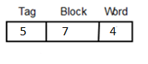 | 3
3. | b) | Consider a pipelined processor that has an average CPI of 1.8 without accounting for memory stalls. I-Cache has a hit rate of 95% and the D-Cache has a hit rate of 98%. Assume that memory reference instructions account for 30% of all the instructions executed. Out of these 80% are loads and 20% are stores. On average, the read-miss penalty is 20 cycles and the write-miss penalty is 5 cycles. Compute the effective CPI of the processor accounting for the memory stalls.  Ans: 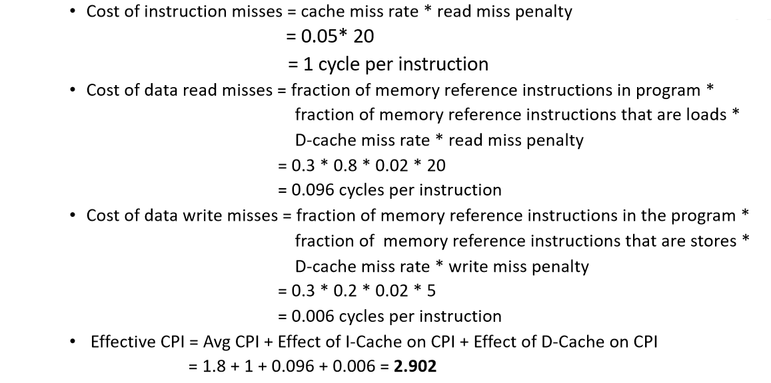 | 04
3. | c) | Discuss briefly the cache coherence problem  If the data in the disk and main memory changes and the write-back protocol is being used,  - The data in the cache may also have changed and is indicated by the dirty bit.  - The copies of the data in the cache, and the main memory are different. This is called the cache coherence problem.  - One option is to force a write-back before the main memory is updated from the disk. | 03
3. | d) | a)Consider a direct mapped cache of size 512 KB with block size 1 KB. There are 7 bits in the tag. Find the Size of main memory  Ans: Cache memory size = 512 KB  Block size = Line size = 1 KB = 2^10, i.e offset is 10 bits  Number of bits in tag = 7 bits  Total number of blocks= 512 kb / 1 kb = 512 blocks or line = 2^9 . i.e 9 bits  The physical address = TAG+ Line number + offset  = 7 bits + 9 bits + 10 bits  = 26 bits  Size of memory is 2^26= 67,108 bytes  b) Write formula for calculating AMAT considering multi-level cache into consideration.  Ans: Miss Penalty_{L1} = Hit Time_{L2} + Miss Rate_{L2} x Miss Penalty_{L2}  Substituting in original equation, we get,  AMAT = Hit Time_{L1} + Miss Rate_{L1} x [Hit Time_{L2} + Miss Rate_{L2} x Miss Penalty_{L2}] | 04  06
4. | a) | STR R3, 512 (R0)  LDR R1, 1024 ( R0)  LDR R2, 512 (R0) Assume Direct mapped ,Write –through cache that maps 512 and 1024 to the same block. Four word write buffer that is not checked on a read miss. Will the value in R2 always be equal to the value in R3? Identify the problem in this.  - Ans: This is a read-after-write data hazard in memory.  - The data in R3 are placed into the write buffer after the STR.  - The following LDR instruction uses the same cache index and is therefore a miss.  - The second LDR instruction, tries to put the value in location 512 into the register R2.  - This also results in a miss.  - If the write buffer hasn’t completed writing to location 512 in memory,  - The read of location 512 will put the old, wrong value into the cache block and then into R2.  - Without proper precautions, R3 would not be equal to R2! | 05
4. | b) | Distinguish between shared memory and distributed memory with neat diagrams  Ans:  SHARED MEMORY:  Changes made by 1 processor can be seen by another.  Types:  - Uniform Memory Access: UMA: AMAT is the same for all the processors  - Non-Uniform Memory Access: NUMA  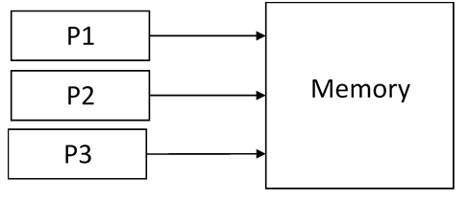  DISTRIBUTED MEMORY:  No global address space.  The method of communication between the processors has to be designed by the programmer.  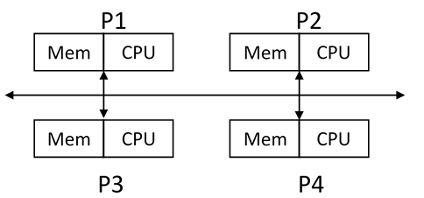 | 05
4. | c) | The total time to execute a program is set to 1. The parallelizable part of the programs consumes 80% of the execution time. What is the execution time of the program with a parallelization factor of 2?  Solution:  The parallelizable part is thus equal = 0.8.  Time for non-parallelizable part is 1-0.8= 0.2 .  The execution time of the program with a parallelization factor of 2 (2 threads or CPUs executing the parallelizable part, so N is 2) would be:  T(2) = (1-0.8) + 0.8 / 2  = 0.2 + 0.4 / 2  = 0.2 + 0.2  = 0.4 | 05
4. | d) | Give the classification according to Flynn  Ans:  SISD:  Only one instruction stream is acted upon in each clock cycle.  Only one data stream is used as input in each clock cycle.  Ex: single CPU workstations and mainframes  SIMD:  A type of parallel computer  All processing units work on the same instruction, at any given clock cycle  Each processing unit can however work on different data elements  Ex: Processor arrays  MISD:  Single data stream is fed onto multiple processing units.  Each processing unit operates on the data via independent instruction streams  Some uses might be: multiple frequency filters operating on a single signal stream  MIMD:  Most modern computers fall into this category.  Every processor can work on independent instructions and with different data stream  Ex: mostly current supercomputers. | 05
5. | a) | What are parallel instructions? Mention different types of parallelisms?  Parallel instructions are a set of instructions that do not depend on each other to be executed. • Hierarchy • Bit Level Parallelism • 16 bit add on 8 bit processor • Instruction Level Parallelism • Loop Level Parallelism • for (i=1; i<=1000; i= i+1) x[i] = x[i] + y[i]; • Thread Level Parallelism • multi-core computers | 04
5. | b) | Consider the following program:  1. e = a + b  2. f = c + d  3. g = e * f,  demonstrate how this program could be executed using ILP?  Ans:Operation 3 depends on the results of "e" and "f" which are calculated from operations 1 and 2, so "g" cannot be calculated until both of "e" and "f" are computed. • However, operations 1 and 2 do not depend on any other operation, so they can be computed simultaneously. • If we assume that each operation can be completed in one unit of time then these three instructions can be completed in a total of two units of time, giving an ILP factor of 3/2; which means 3/2 = 1.5 greater than without ILP | 04
5. | c) | Mention the micro architectural techniques that include ILP:  Ans:Instruction Pipelining • Superscalar • Out-of-Order Execution • Register Renaming • Speculative Execution • Branch Prediction | 04
5. | d) | i) Briefly mention how traditional multicore architecture can be classified?  Ans: Tightly coupled multiprocessors:  The processors access common shared memory • Inter Processor Communication takes place through shared memory  Loosely coupled multiprocessors:  Memory distributed among the processors • Processors typically communicate through a high-speed connection network  ii) Describe the memory organization in multicore processors:  Ans: L1 caches are private  • L2 caches private in some architectures and shared in others  • Last levels of memory is always shared  iii) Mention the applications that benefit from multicore  Ans: Database Servers • Web Servers • Compilers • Multimedia Applications • Scientific Applications • In general, applications with thread level parallelism | 03  03  02

